A
Internship Report
on

“Python Full Stack Web Based User Management System”

By

Sushant Dongardive
(Font Size 14)

Guided by
Prof. Namrata Jangam



Department of Computer Engineering
Vidya Prasarini Sabha’s college of Engineering
and Technology, Lonavala

[2026-2027]
Vidya Prasarini Sabha’s college of Engineering and Technology, Lonavala



C E R T I F I C A T E

This is to certify that Mr. Sushant Dongardive has successfully completed the Internship entitled “Python Full Stack Web Based User Management System” under my supervision, in the partial fulfillment of Bachelor of Engineering (Computer) of Savitribai Phule Pune University, Pune.(

Date:

Place: Lonavala

Name of Guide: Head Of Deparment:
Prof. Namrata Jangam Prof. Namrata Jangam

External Exam

Principal
Dr. Manav A. Thakur

Institute Seal

ACKNOWLEDGEMENT (Font Size 16)

It is a matter of great satisfaction an pleasure to present the dissertation on Python Full Stack Web Based User Management System with great pleasure we express our deep sense of gratitude to our guide Prof. Namrata Jangam, for her valuable guidance, discussion and constant encouragement for successful completion of this Internship. She gave us suggestion and constructive input time to time in friendly manner, which is perhaps a unique characteristics nature of her mind. We are thankful Prof. Namrata Jangam (Internship Guide) for all her support and her guidance for all the current work. for his kind co-operation and help. We will fail in our duty if we want acknowledge a great sense of graduate to Dr. Manav A. Thakur (Principal) for his kind co-operation. we would like to thank department and library staff at V. P. S college of engineering and technology, Lonavala , for their attitude towards the completion of this Internship. we would also like to our friends and our parents to help us directly and indirectly in the successful completion this Internship.

Thanking you,

Principal
Dr. Manav A. Thakur

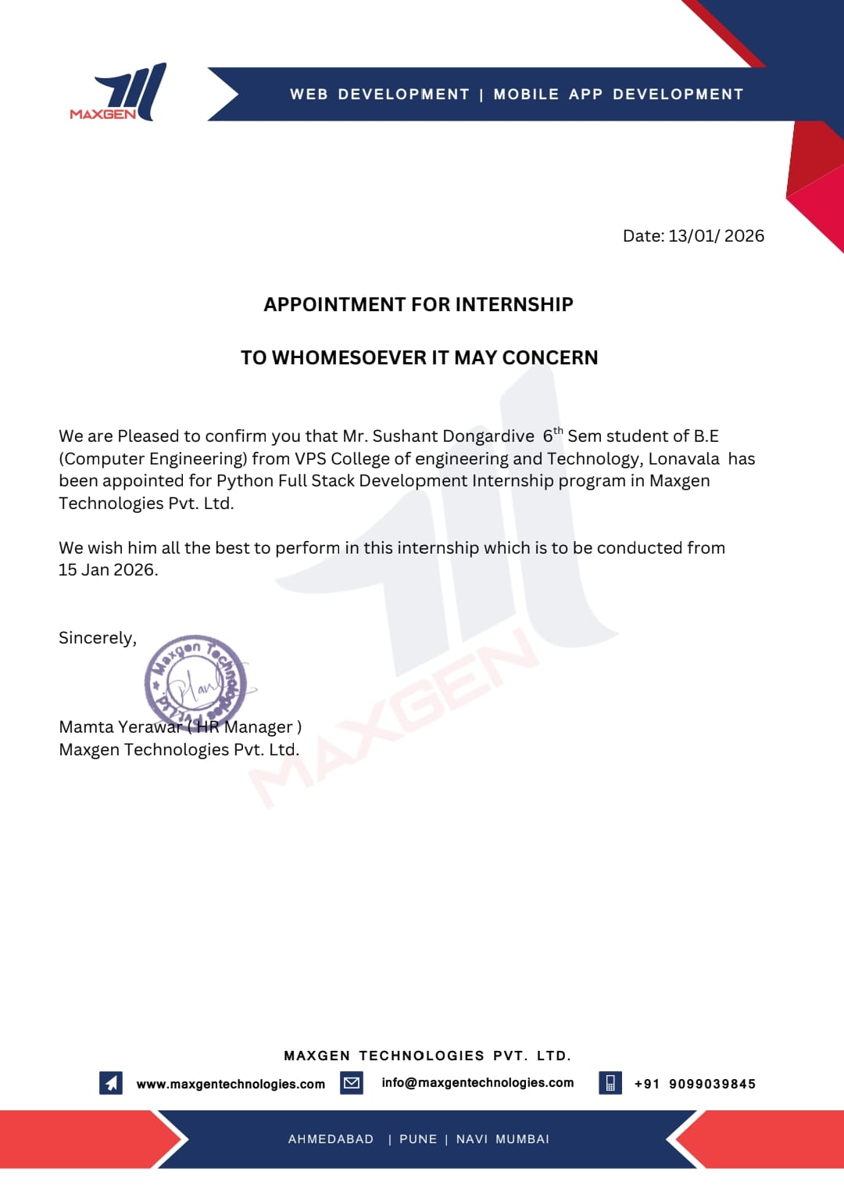

Introduction of Maxgen Technologies

Maxgen Technologies Pvt Ltd is a well-known IT training and development company in India that provides professional training programs and internship opportunities for students in various technology domains. The company focuses on bridging the gap between academic learning and industry requirements by offering practical training and real-time project exposure.
Maxgen Technologies offers training in several fields such as Python Full Stack Development, Java Development, Data Science, Artificial Intelligence, Machine Learning, Web Development, and Digital Marketing. The company helps students develop practical skills through hands-on projects, workshops, and guided learning sessions conducted by experienced trainers.
The organization mainly aims to improve students’ technical knowledge and prepare them for the software industry. Through its internship programs, students learn about real-world development practices such as software design, coding standards, debugging, testing, and deployment.
Maxgen Technologies has training centers in different cities across India and has trained thousands of students from engineering and computer science backgrounds. The company focuses on providing quality training, project guidance, and skill development that helps students build confidence and enhance their career opportunities in the IT sector.
During the internship at Maxgen Technologies, students get the opportunity to work on practical projects related to their technology domain. This helps them understand the software development lifecycle and gain experience in using modern tools and technologies.

ABSTRACT
The rapid growth of web technologies has increased the demand for efficient and scalable web applications. Python has become one of the most popular programming languages for web development due to its simplicity, flexibility, and large ecosystem of frameworks and libraries. This internship project focuses on the design and development of a Python Full Stack Web Application that integrates frontend technologies, backend processing, and database management.
The main objective of this project is to develop a web-based system that allows users to register, log in, and manage their data through an interactive web interface. The system uses HTML, CSS, and JavaScript for the frontend interface and Python with Flask/Django framework for backend processing. The application communicates with a relational database such as MySQL or SQLite to store and retrieve user information securely.
The system follows a layered architecture consisting of the presentation layer, application layer, and database layer. The presentation layer handles user interaction through web pages, the application layer processes business logic and authentication, and the database layer manages persistent storage of user data. The project also implements basic security features such as login authentication and data validation.
This internship project provides practical exposure to modern web development technologies and demonstrates how different components of a web application work together. The developed system is scalable, user-friendly, and can be extended in the future with additional features such as API integration, cloud deployment, and advanced security mechanisms.
The project helps in understanding the complete software development lifecycle including system design, development, testing, and deployment. It also enhances programming skills and knowledge of full stack web development.

Index

CHAPTER 1 – INTRODUCTION PAGE NO:-
1.1 Overview of Python Full Stack Development 02
1.2 Motivation of the Project 03
1.3 Objectives of the Project 04
1.4 Scope of the Project 05
CHAPTER 2 – LITERATURE REVIEW / BACKGROUND 06
2.1 Introduction to Web Development 07
2.2 Python Programming Language 08
2.3 Frontend Technologies (HTML, CSS, JavaScript) 08
2.4 Backend Framework (Django / Flask) 09
2.5 Database (MySQL / SQLite) 09
2.6 Existing Systems 09
2.7 Limitations of Existing Systems 10
CHAPTER 3 – PROPOSED SYSTEM 11
3.1 Overview of Proposed System 12
3.2 System Architecture 12
3.3 Technology Stack Used 13
3.4 Modules of the System 14
3.4.1 User Authentication Module 14
3.4.2 User Interface Module 14
3.4.3 System Workflow 14

CHAPTER 4 – IMPLEMENTATION AND RESULTS 15
4.1 Development Environment 16
4.2 Database Design 16
4.3 Implementation Steps 16
4.4 Testing of the System 17
4.5 Result and Output Screenshots 17
CHAPTER 5 – CONCLUSION AND FUTURE SCOPE
5.1 Future Scope
5.2 Conclusion
5.3 Refference

LIST OF FIGURES
Figure No. | Figure Name | Page No.
3.2.1 | System Architeture | 12
4.5.1 | Login Page | 17
4.5.2 | Registration Page | 18
4.5.3 | User Dashboard | 18
4.5.4 | Admin Panel | 19

CHAPTER 1
INTRODUCTION

  - INTRODUCTION

Python Full Stack Development refers to the development of both the front-end (client side) and back-end (server side) of a web application using Python and related technologies. A full stack developer works on every layer of the application including the user interface, server logic, database operations, and application integration.
In modern web development, applications are expected to be fast, scalable, and interactive. Python has become one of the most popular programming languages for web development due to its simplicity, readability, and large ecosystem of frameworks and libraries.
A typical Python full stack application consists of three main components:
- Front-End Technologies
  - HTML
  - CSS
  - JavaScript
- Back-End Technologies
  - Python
  - Frameworks such as Flask or Django
- Database
  - MySQL
  - SQLite
  - PostgreSQL
The frontend provides a graphical interface for users to interact with the system. The backend processes requests from the user and communicates with the database to store or retrieve information.
Python frameworks such as Flask and Django make development easier by providing built-in tools for routing, database integration, authentication, and security.
Full stack development allows developers to understand the complete workflow of web applications from user interaction to database processing.

  - Motivation of the Project

The rapid growth of internet technology has increased the demand for web-based applications in almost every field such as education, healthcare, business, and entertainment.
Traditional software systems required installation on individual machines, but web applications allow users to access services from anywhere using a browser.
The motivation for developing a Python full stack application includes:
- To build scalable and efficient web applications.
- To learn real-world software development practices.
- To understand the integration between frontend and backend technologies.
- To improve skills in database management and web frameworks.
Python provides a simple and powerful programming environment, which makes it ideal for students and developers to learn full stack development.
The internship project aims to provide practical exposure to real-world web development, including application design, development, testing, and deployment

  - Objectives of the Project

The main objectives of this internship project are:
- To understand the fundamentals of web application development.
- To design and develop a full stack web application using Python.
- To implement user authentication and data management features.
- To integrate frontend technologies with backend logic.
- To manage data using a relational database system.
- To develop a responsive and user-friendly interface.
- To gain practical knowledge about software development lifecycle.
The project also focuses on improving coding practices and understanding modern development tools used in the software industry.

  - Scope of the Project

The scope of the Python Full Stack project includes the development of a web-based system that allows users to interact with the application through a browser interface.
The system includes the following functionalities:
- User registration and login
- Data storage and retrieval
- Admin management features
- User-friendly interface
- Secure authentication system
The application can be used as a base system for various domains such as:
- Online management systems
- E-learning platforms
- Task management systems
- Blog or content management systems
The system can also be expanded in the future by adding features such as API integration, cloud deployment, and mobile compatibility

CHAPTER 2
BACKGROUND AND RELATED WORK

2.1 Introduction to Web Development

Web development refers to the process of creating websites or web applications that run on the internet or intranet. It involves designing user interfaces, writing server-side logic, and managing databases.
Web development is generally divided into two main categories:
- Frontend Development
- Backend Development
Frontend development focuses on the visual components of a website that users interact with directly. Backend development focuses on processing requests, managing data, and performing server-side operations.

2.2 Python Programming Language

Python is a high-level, interpreted programming language known for its simplicity and readability. It supports multiple programming paradigms including object-oriented, procedural, and functional programming.
Python is widely used in several fields such as:
- Web development
- Artificial intelligence
- Data science
- Automation
- Cybersecurity
Advantages of Python include:
- Easy to learn and use
- Large community support
- Rich library ecosystem
- Cross-platform compatibility

2.3 Frontend Technologies (HTML, CSS, JavaScript)

Frontend technologies are responsible for creating the visual structure of a web application.
HTML
HTML (HyperText Markup Language) is used to create the structure of web pages.
CSS
CSS (Cascading Style Sheets) is used to style and design the layout of web pages.
JavaScript
JavaScript is used to create interactive features such as animations, form validation, and dynamic content updates.

2.4 Backend Frameworks (Flask / Django)

Backend frameworks simplify the process of building web applications by providing built-in functionalities.
Flask
Flask is a lightweight Python framework used for building simple web applications.
Django
Django is a high-level framework that follows the Model-View-Template (MVT) architecture.
It provides built-in features such as:
- Authentication system
- Database ORM
- Admin panel
- Security protection

2.5 Database Systems (MySQL / SQLite)

A database is used to store and manage application data.
MySQL
MySQL is a popular relational database management system used for web applications.
SQLite
SQLite is a lightweight database system often used for small applications and testing.

2.6 Existing Systems

Many existing web applications use different programming languages and frameworks to manage data and user interactions.
Traditional systems often rely on separate frontend and backend technologies which increases development complexity.

2.7 Limitations of Existing Systems

Some limitations of traditional systems include:
- High development cost
- Complex system architecture
- Limited scalability
- Security vulnerabilities
Python full stack development helps overcome many of these challenges by providing a simplified development environment and powerful frameworks.

CHAPTER 3
PROPOSED SYSTEM

3.1 Overview of Proposed System

The proposed system is a Python-based full stack web application designed to provide efficient data management and user interaction.
The system allows users to register, log in, and access application features through a web interface.

3.2 System Architecture

The system architecture consists of three layers:
- Presentation Layer (Frontend)
- Application Layer (Backend)
- Data Layer (Database)

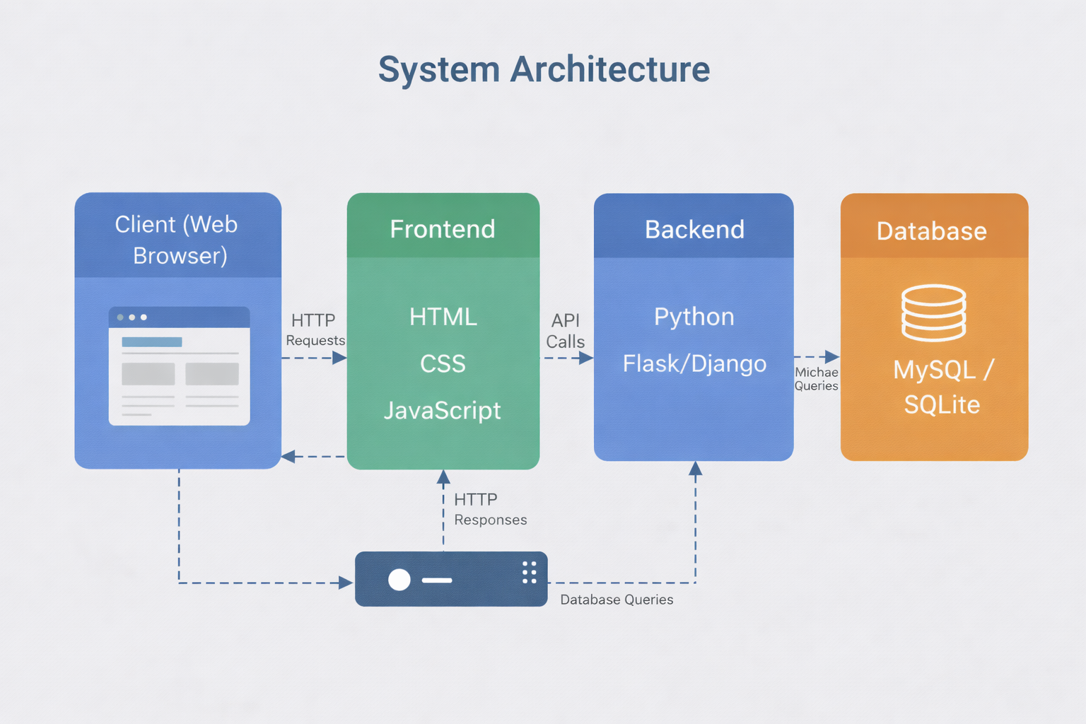

3.2.1 System Architecture

3.3 Technology Stack

The following technologies are used in the system:
Frontend:
- HTML
- CSS
- JavaScript
Backend:
- Python
- Flask / Django
Database:
- MySQL / SQLite

3.4 Modules of the System

The system contains the following modules:
- User Module
- Admin Module
- Authentication Module
- Database Module

3.5 System Workflow

The system workflow includes the following steps:
- User accesses the web application.
- User registers or logs into the system.
- The backend processes the request.
- The database stores or retrieves data.
- The system displays results on the user interface

CHAPTER
IMPLEMENTATION AND RESULTS
4.1 Development Environment

The development environment used for the project includes:
- Python programming language
- Visual Studio Code
- Flask or Django framework
- MySQL database
- Web browser for testing

4.2 Database Design

The database stores user information and application data.
Tables include:
- User Table
- Admin Table
- Data Records Table

4.3 Implementation Process

The implementation process includes the following steps:
- Designing the system architecture
- Creating the database structure
- Developing frontend pages
- Implementing backend logic
- Integrating database operations
- Testing the system

4.4 Testing

Testing ensures that the application works correctly.
Types of testing performed include:
- Unit testing
- Integration testing
- System testing

4.5 Results and Output

The system successfully performs the following functions:
- User registration
- Login authentication
- Data management
- User interaction through web interface
Screenshots of the application interface can be included in this section.
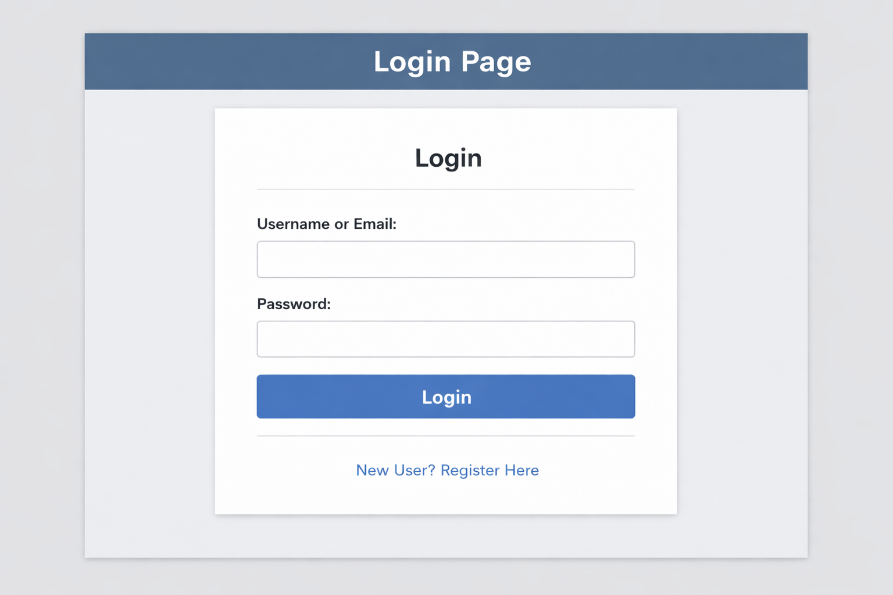
4.5.1 Login Page

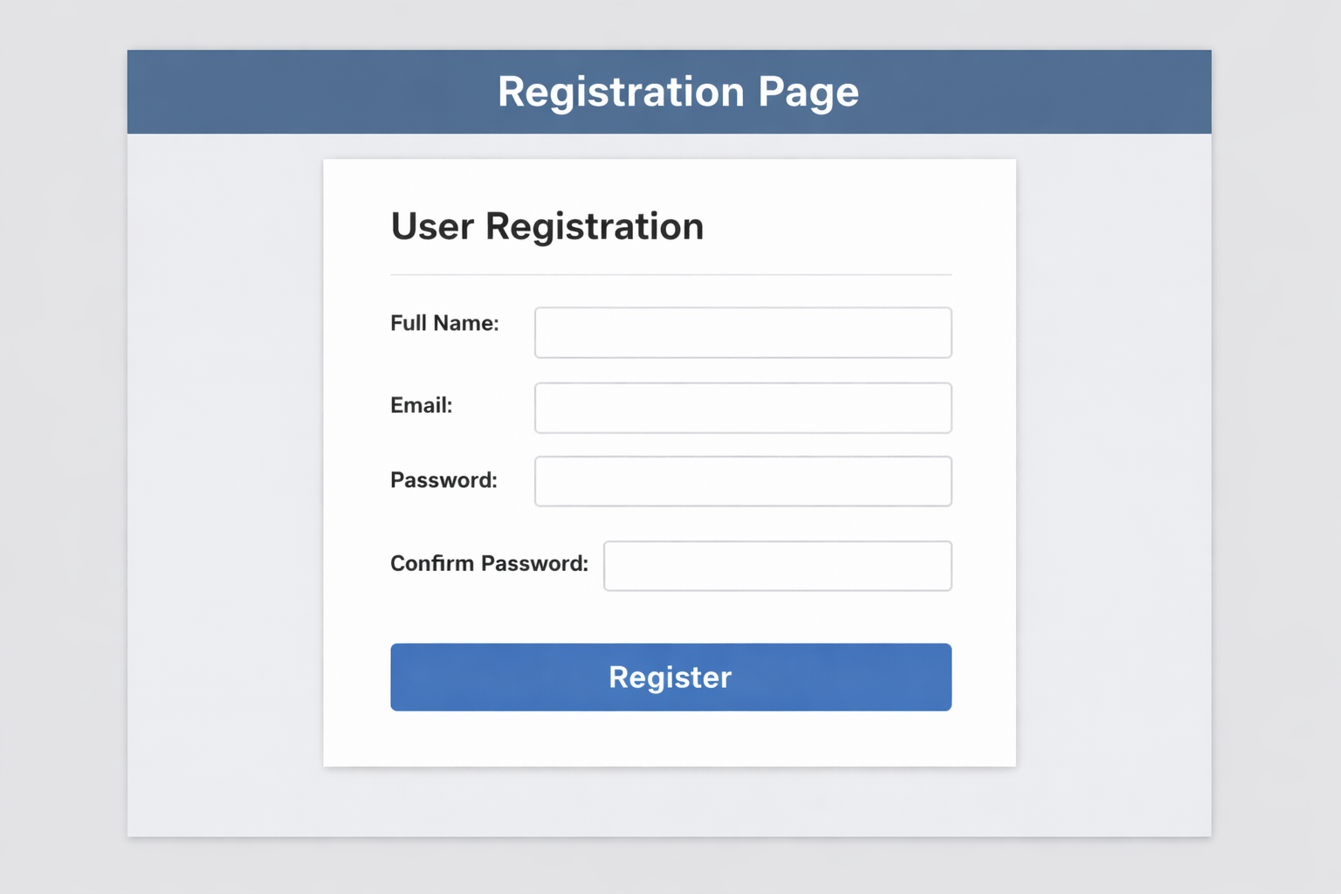
4.5.2 Registration Page

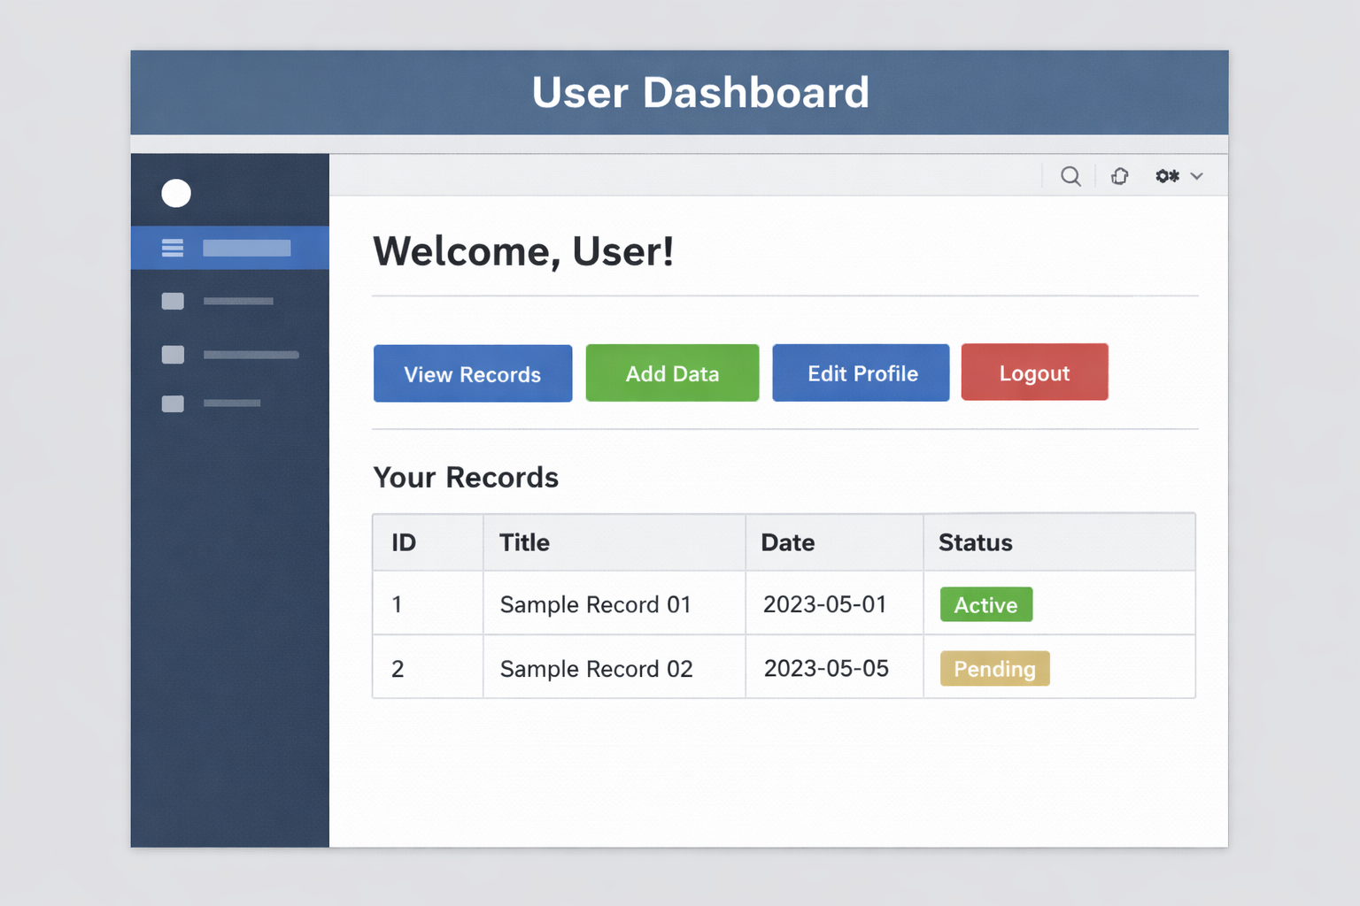
4.5.3 User Dashboard

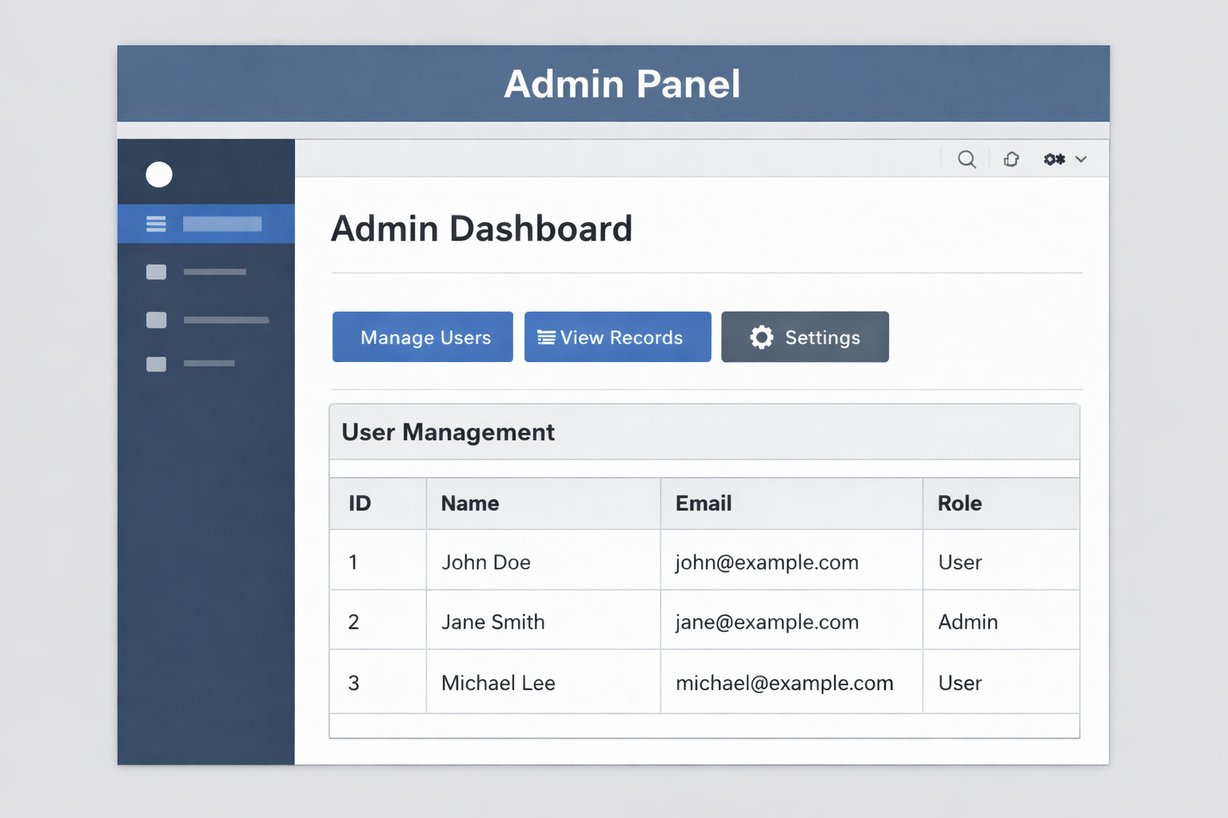
4.5.4 Admin Panel

FUTURE SCOPE(Font Size 16)

The project can be enhanced in the future by adding advanced features such as:
- Cloud deployment
- Mobile application integration
- REST API development
- Machine learning integration
- Improved security mechanisms
These improvements can make the application more scalable and suitable for real-world usage.

CONCLUSION

The Python Full Stack internship project provided valuable experience in designing and developing a complete web application.
The system demonstrates the integration of frontend technologies with backend logic and database management.
Python frameworks such as Flask and Django significantly simplify the development process.
The project helped in understanding the software development lifecycle, debugging techniques, and deployment strategies.

REFERENCES(Font Size 16)

    - Gonzalez, R.C., Woods, R.E., “Digital Image Processing”. Prentice Hall, 2007
    - Anindya Sarkar, Pratim Ghosh and B.S. Manjunath, Efficient and Robust Detection of Duplicate Videos in a Large Database. IEEE Transactions on circuits and systems for video technology, pages 470–485, 2011.
    - Wei-Lun Chao,” Introduction to Video Fingerprinting”.
    - A. Joly, O. Buisson, and C. Frelicot. Statistical similarity search applied to content- based video copy detection. Int. Conf. on Data Engineering Workshops, page 1285, 2005.
    - J. Law-To, L. Chen, A. Joly, I. Laptev, O. Buisson, V. Gouet-Brunet, N. Boujemaa, and
F. Stentiford. Video copy detection: a comparative study. In Proc. of CIVR, pages 371– 378. ACM, 2007.
    - L. Liu, W. Lai, X. Hua, and S. Yang. Video Histogram: A Novel Video Signature for Efficient Web Video Duplicate Detection. Lecture Notes in Computer Science, 4352:94–103, 2007.

